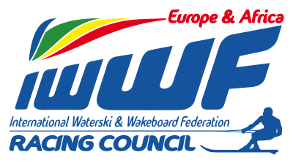 Competitor’s Corner

Info – News Bulletin: 2/2015

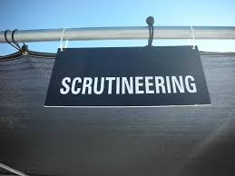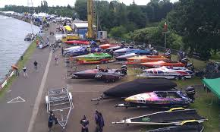

E&A is currently seeking new scrutineers to strengthen it’s current team.

The role of the scrutineer is to help the competitors to compete in a safe and legal manner compliant with the E&A regulations.

If you are interested in finding out more about scrutineering please send your application to E&A racing secretary Vera Van Den Bossche – email vera.vdbossche@skynet.be

Looking forward to welcoming you to our team!

Yours in Water-ski Racing
Chris RYDL
Athlete’s Rep E&A

